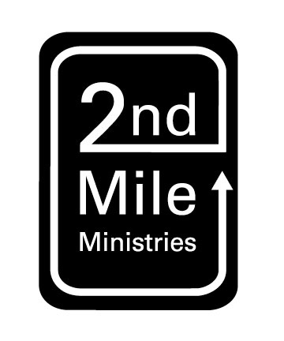

***As you answer the following questions it is important for you to know that we just want to know who you are. Don’t get stressed out about giving what you think is the “right” answer. Be honest!***

How did you find out about 2nd Mile Ministries?

What motivated you to apply?

What is your favorite Christian book(s) (besides the Bible) and why?

**Intern Application**

Marc Nettleton

[marc@2ndmilejax.com](mailto:marc@2ndmilejax.com)

904-274-1671

**Name_______________________________________________ Date______________________**

**Age_________ Birthdate___________________** ☐ **Male** ☐ **Female**

**Street Address_________________________________________________________________**

**City______________________________ State____________ Zip Code___________________**

**Phone__________________________**

**E-mail Address_______________________________________**

**School___________________________ Years Completed_____________ Graduated_______**

**Major____________________________**

**Place of Employment______________________________ Years Employed_______________**

**Interested in:** ☐ **Summer (dates available:________________)** ☐ **1-Year**

List 6 things you love: (whatever comes to mind)

Do you have any particular skills or talents?

Would you prefer to be with others or by yourself?

Would you prefer to debate or that everyone would just get along?

How do you handle failure?

Rate yourself in the following areas: 1 (lowest) to 5 (highest)

____Dependability

____Desire to learn

____Self-confidence

____Sensitivity towards others

____Ability to work hard

____Punctuality

____Acceptance of Christians who practice Christian faith differently

____Flexibility

____Current involvement in ministry

____Passion for justice

____Familiarity with urban ministry

Describe the church with which you are most actively involved. What has your involvement been?

Church’s Name:___________________________ Denomination:_____________________________

Pastor’s Name:_______________________________________

How long have been at this church:

Are you presently involved with a dating relationship?

If yes, how long have you been involved? Is it serious? How do you anticipate this relationship affecting your time with 2nd Mile?

Please answer the following questions on a separate sheet of paper:

1. Please share with me when and how you became a Christian. Tell me about your current relationship with God. How does that relationship look?
2. What are you learning from in your relationship with God?
3. What are areas you are struggling with in your relationship with God?
4. Why are the poor, poor?
5. Does racism exist in America? If so, how does it look? If not, explain why you think so?
6. What are the most important issues the church should be dealing with today?

Please choose two references from the following list: Your pastor/spiritual leader, supervisor, teacher, mentor, or other significant adult (not a peer or family member). List them below. Make sure to contact them to let them know they will be hearing from us.

Name:_______________________________ Email: ______________________________

Phone: ______________________________

Name:_______________________________ Email: ______________________________

Phone: ______________________________

Send to: 2nd Mile Ministries

1650 Margaret St

Suite 302, #339

Jacksonville, FL 32204

or e-mail to: marc@2ndmilejax.com